|  |
| --- |
| Central Queensland University, Sydney |
| Guide to deploy application  Rotary Youth Drive Awareness Project |
| COIT20273: Software Design and Development Project |
|  |
| Lecturer/Tutor: Zakiullah Khan Course Coordinator: Dr. Lily Li |
| **Due date: 9/22/2017** |

Project Members:

Bijay Shahi (12021856)

Keshav Khadka (S0280624)

Pratik Shrestha (S0282733)

|  |  |  |  |
| --- | --- | --- | --- |
| **S.N.** | **Document Name** | **Version** | **Revision Date** |
| 1. | Guide to deploy application | 1.0 | 2017-09-22 |

Table of Contents

1. Create and configure JDBC connection pool 3

2. Compile the application 3

3. Deploy the application 4

# 1. Create and configure JDBC connection pool

1. Run command prompt.
2. Type startnetworkserver and press enter which will start the database server.



1. Open another command shell and type asadmin start-domain and press enter which will start the Glassfish server.

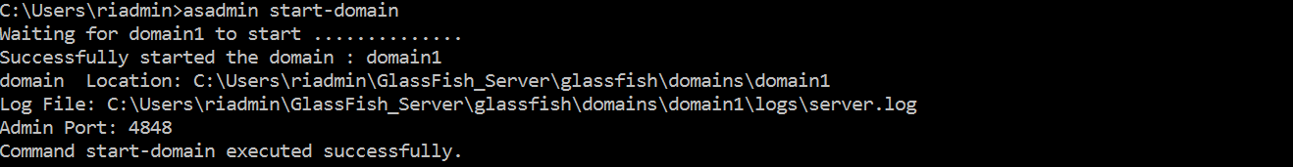

1. Create connection pool with following commands:
   1. Command to create JDBC connection pool

asadmin create-jdbc-connection-pool --datasourceclassname=org.apache.derby.jdbc.ClientDataSource --restype=javax.sql.DataSource --property portNumber=1527:password=APP:user=APP:serverName=localhost:databaseName=RYDADB:connectionAttributes=;create\=true RYDAPool

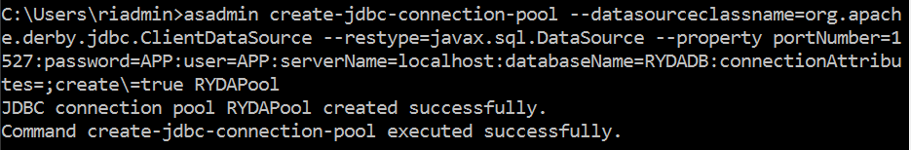

* 1. Command to test and verify the pool

asadmin ping-connection-pool RYDAPool



* 1. Command to create JDBC resource

asadmin create-jdbc-resource --connectionpoolid RYDAPool jdbc/RYDADS

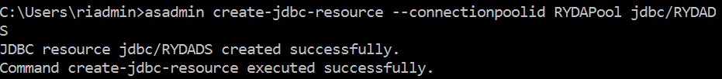

# 2. Compile the application

1. Extract the .zip file and import the project into netbeans.
2. Open persistence.xml file and locate data source with <jta-data-source>jdbc/RYDADS</jta-data-source>

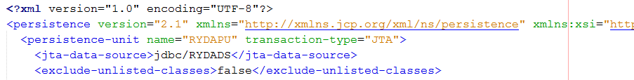

1. Once all set, right click on the project and click on Clean and Build.

# 3. Deploy the application

1. After the JDBC connection pool and data source have been created, go to the project folder and open command prompt by pressing Shift + Right click.
2. Type asadmin deploy --force=true dist\RYDA.war



1. Open glassfish server in browser with url http://localhost:4848
2. Click on the Applications menu

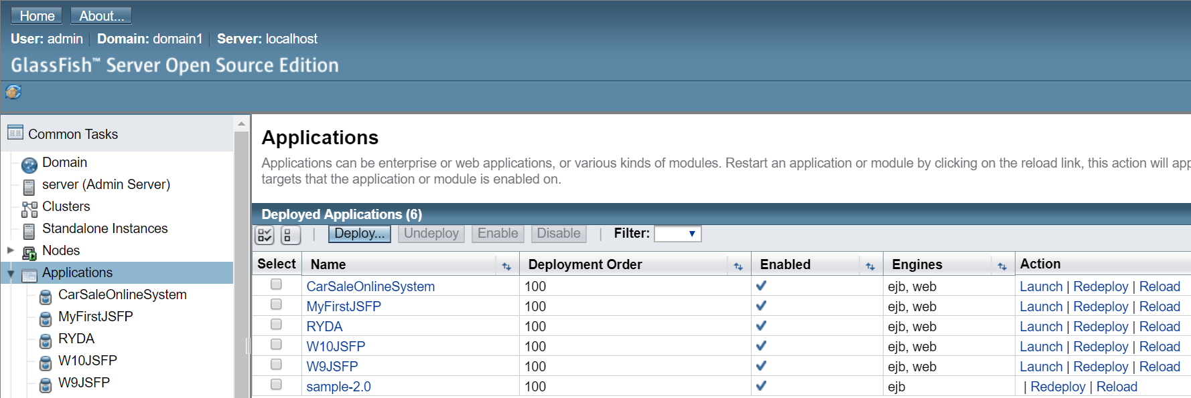

1. Click on Launch button of deployed application RYDA.
2. Click on any of the web application links that will redirect to the RYDA application.

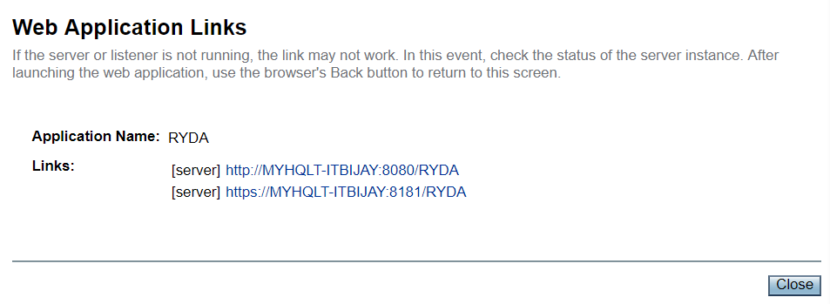

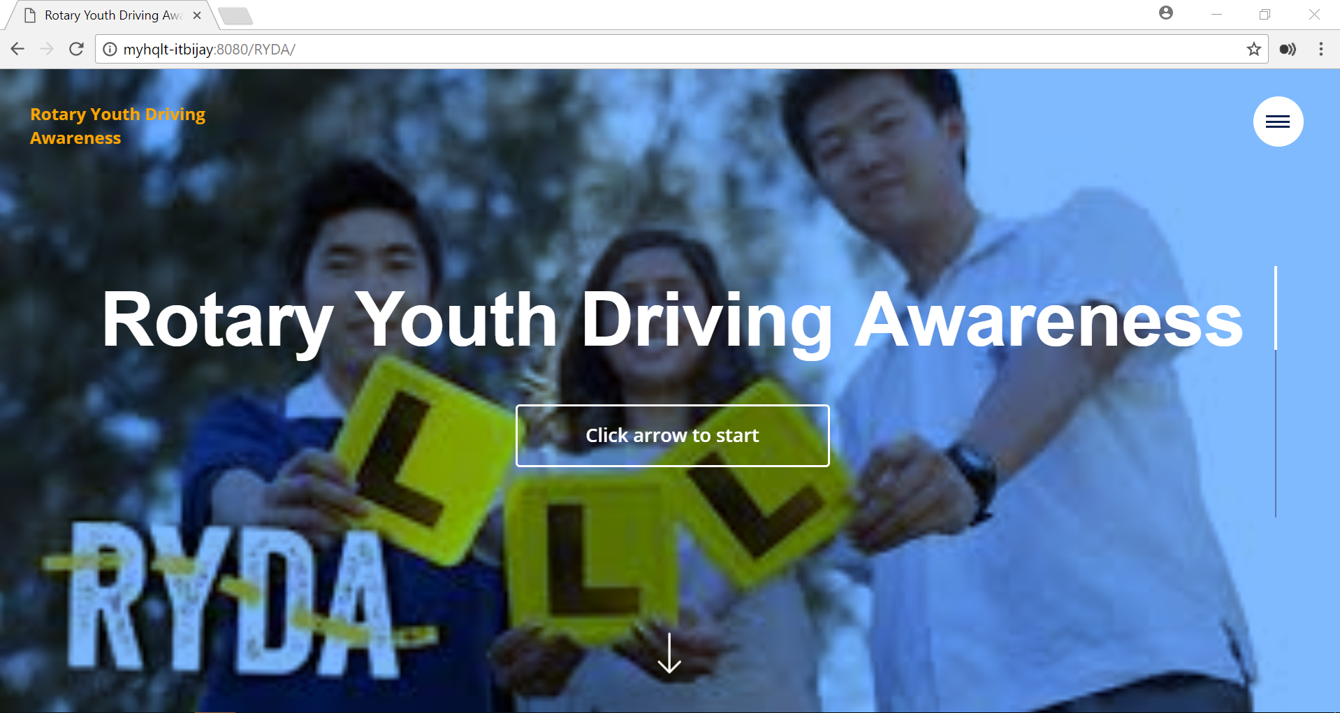

Fig. Rotary Youth Driving Awareness Home Page